

**Assignment 1**

**Group Members:**

I191771 Jiyad Khan

I191696 Yahya Ahmed

**Section:** BS-DS (N)

**Course’s Name:** Technical and Business Writing

**Instructor’s Name:** Ma’am Aniqa Jahangeer

**Submitted Date:** November 14th, 2021

Table of Content

1. Preface …………………………………………………………………………………………………… 3
2. Requirements ………………………………………………………………………………………… 4
3. Installing the tool …………………………………………………………………………………… 4
4. Selecting citation style ……………………………………………………………………………. 8
5. Creating citation for different types of sources ………………………………………. 9
6. Editing and Managing Citations for a project …………………………………………..10
7. Saving selected references or citations from online sources ……………………10
8. Instant formatting ……………………………………………………………………………………11

**Preface:**

EndNote20 software is a software that will help you to create and manage the reference for your document. So that, this software will help you to detect the less plagiarism for your document. User of this document will have a knowledge about the EndNote Software and what are the software’s usage. This document will cover

1. Installing the tool
2. Selecting citation style
3. Creating citation for different types of sources
4. Editing and Managing Citations for a project/research/paper
5. Saving selected references/citations from online sources.
6. Instant formatting

**Requirements:**

In order to install the EndNote20 Software, You are require to have a following things:

* Windows (7,8,10 or XP)
* 156 MBs require storage
* Microsoft 360 (including MS Words, MS PowerPoint)

**Installation of EndNote20 Software:**

* Open and log into your computer.
* Click and Open the Google Chrome.
* After the opening the Chrome, Type the following link in the search bar:

<https://endnote.com/downloads/30-day-trial>

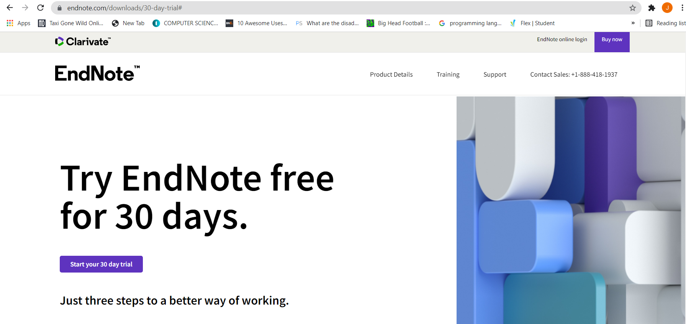

* Download the crack file from the link (As it is a free version to everyone for 30 days).
* After downloading the file, you will click right on the compressed file and click the extract here to extract the file.

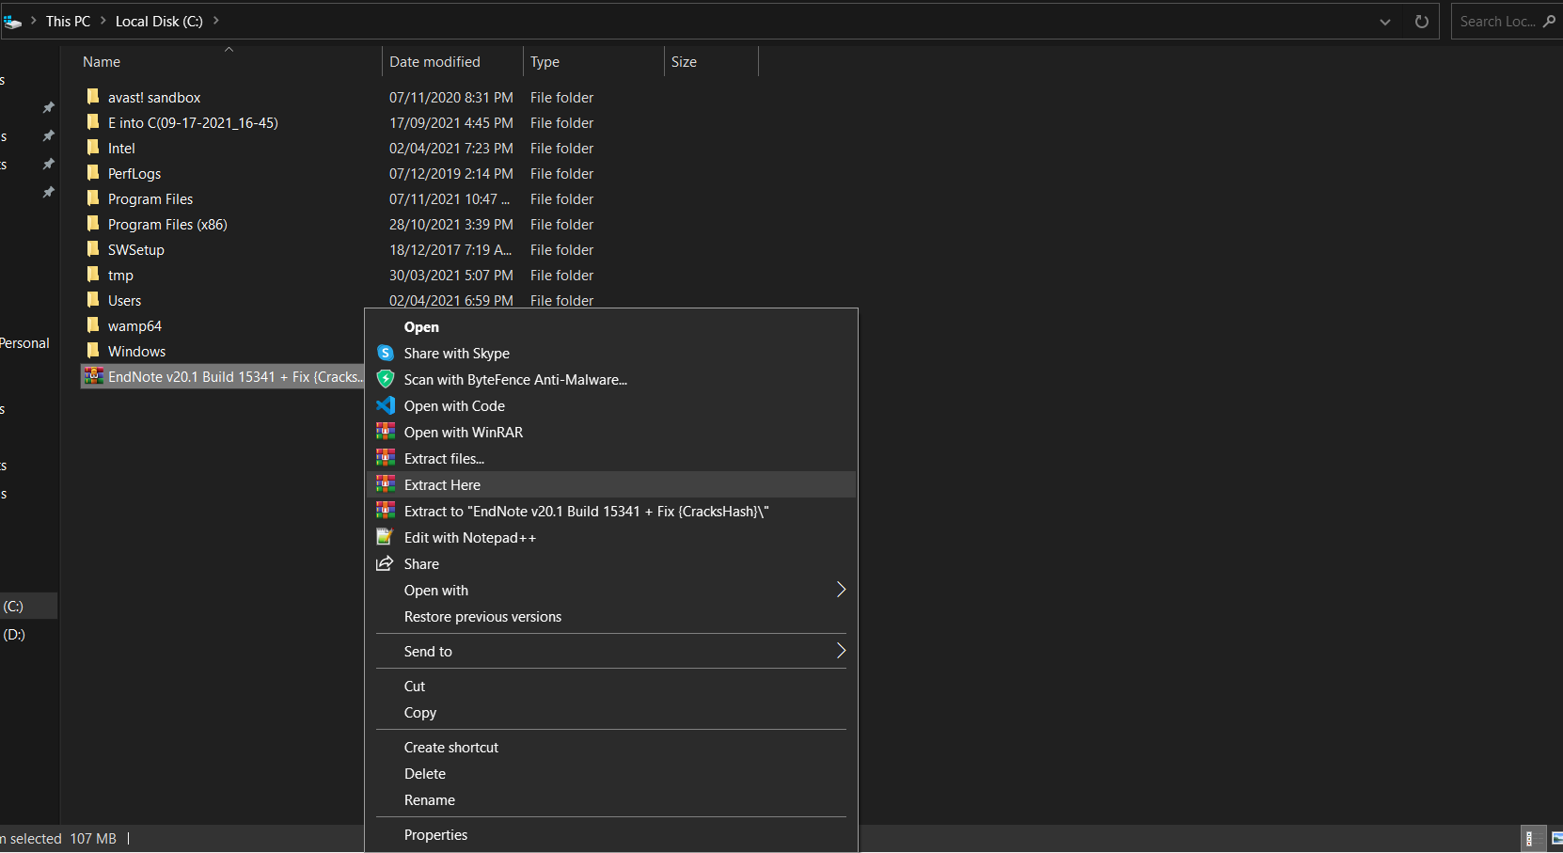

* Click the unzipped folder to open it.
* Then click the SetUp folder to open it.
* Then click the EN20Inst.exe to file in the folder.

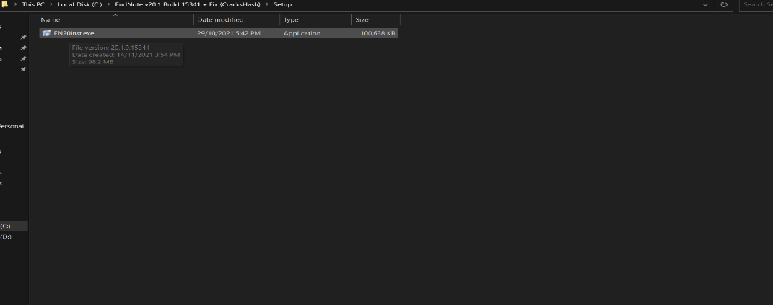

* After clicking the file, this type of setup will appear on the screen. 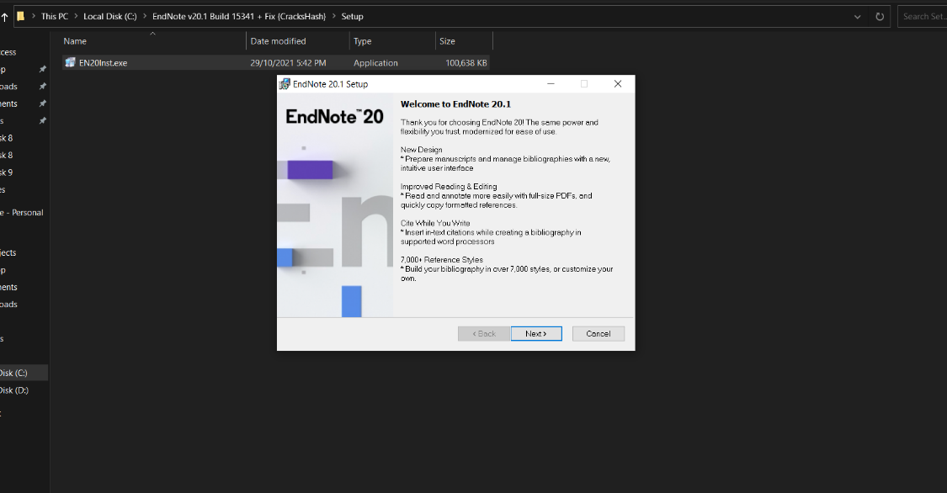
* Click on the next.
* After clicking on the next, Select installation method will appear on the screen having two option:

1. I have a Product Key.
2. I would like to have a 30 day free version.

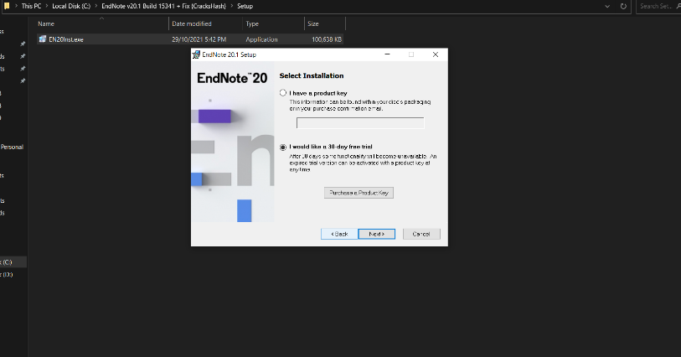

* Click on the 2nd option and click on the next.
* After clicking on the next, readme info will be appear on the screen.
* Read the information and click on the next.
* After clicking on the next, License Agreement will be appear on the screen having two option:
* I accept the agreement.
* I do not accept the agreement.

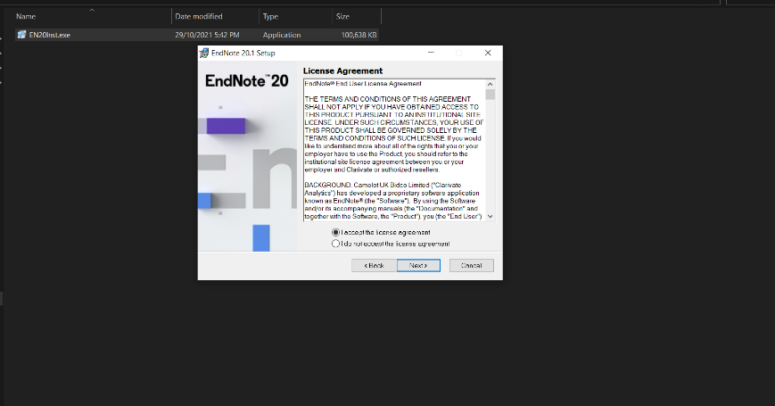

* Click on the 1st option and click on the next.
* After clicking on the next, Installation type will be appear on the screen having two option:
* Typical.
* Custom.

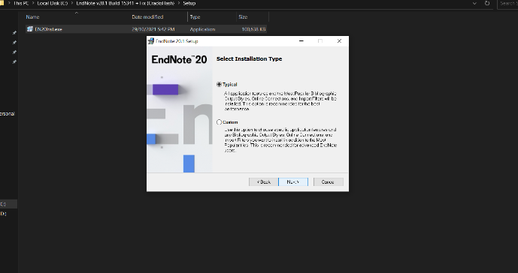

* Click on the 1st option and click on the next.
* After clicking on the next, Select Destination will be appear on the screen.
* Go with your destination folder and click on the next.

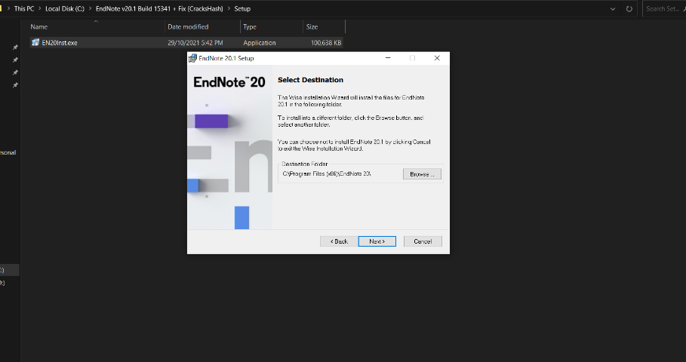

* After clicking on the next, ready to install the application will be appear on the screen.
* See the information and click on the next.
* After clicking on the next, Endnote has been successfully installed will be appear on the screen.

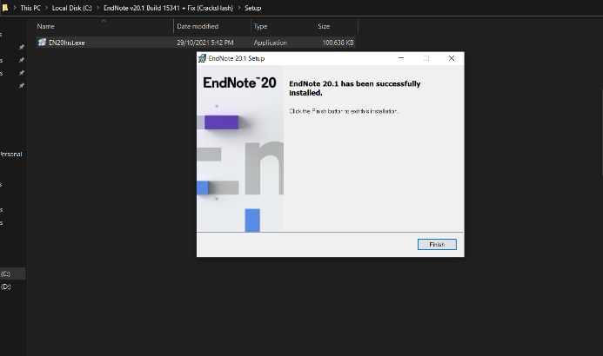

* After seeing this, you will search the EndNote in your computer search bar.
* If it will appear on your screen, then you has been successful install in your computer.

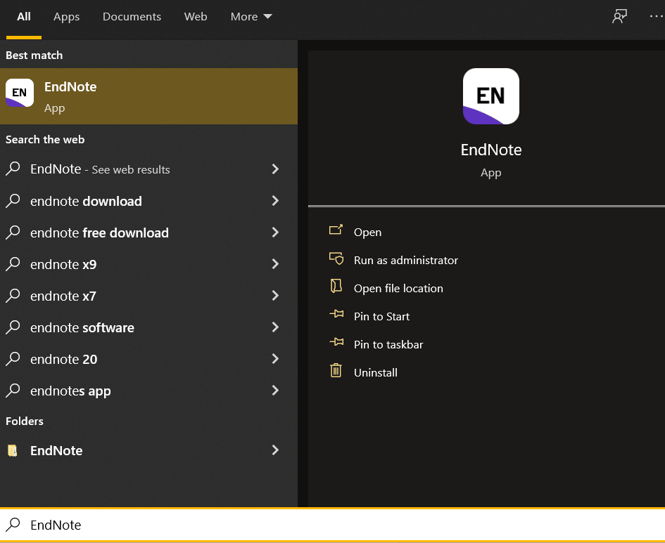

**Selecting Citation Style:**

Citation is required to avoid the plagiarism as you refer someone else the work by highlighting different kind of style in the content. For selecting the citation style, you have to follow the following steps to use the citation style:

* Select the text you wanted to select by clicking or highlighting the text.
* After clicking or highlighting the text, click the tools on the top left side.
* After clicking the tools, there is an option of Output Styles.
* Click on the Output Styles.
* After clicking on the Output Styles, there are different kind of styles will display.
* Select one of the styles.

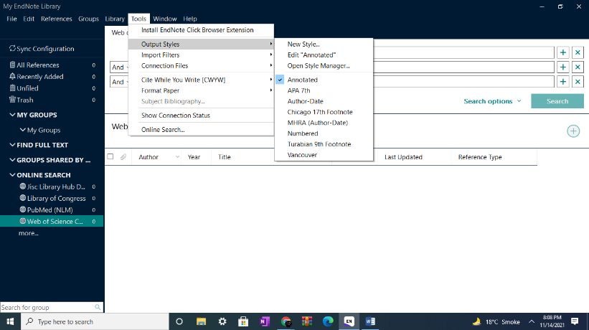

**Creating Citation for Different Types of Sources:**

For creating citation for different types of sources, you have to follow the following steps to creating the citation:

* There is an option of the ‘All Reference’ on the left.
* Click on the All Reference.
* After clicking on the All Reference, there is a sign of ‘+’ on the right side.
* Click on the ‘+’ sign.
* After clicking on the ‘+’ sign, this kind of library will appear on the screen.

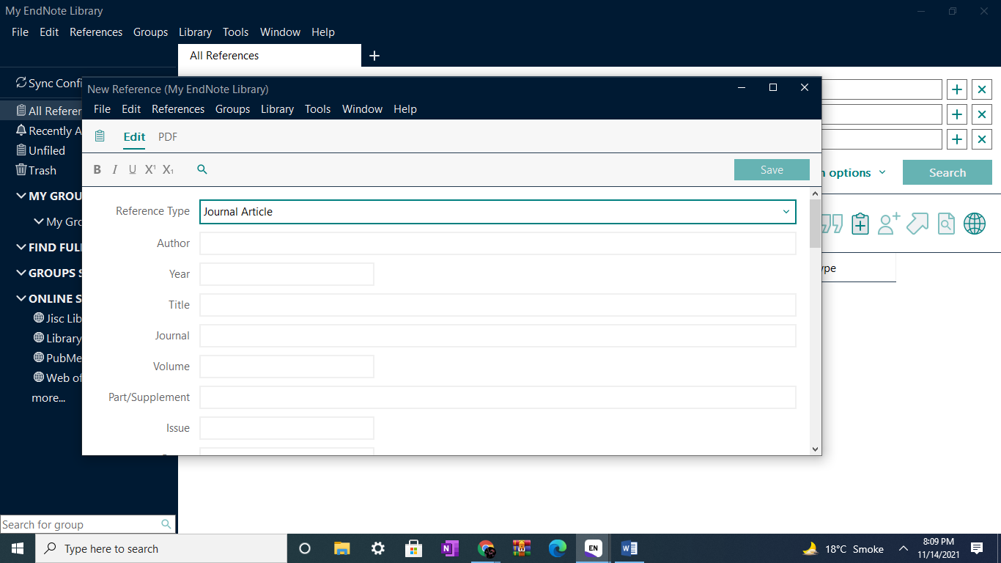

* Through this, we can create the citation through different kind of sources.

**Editing and Managing Citations for a Project:**

For editing and managing citations for a project, you have to follow the following step to editing and managing citations:

* There is an option of the ‘All Reference’ on the left.
* Click on the All Reference.
* After clicking on the All Reference, if you want to edit something then double click on them.
* After double clicking on the text, this kind of windows will appear on the left side of your screen.

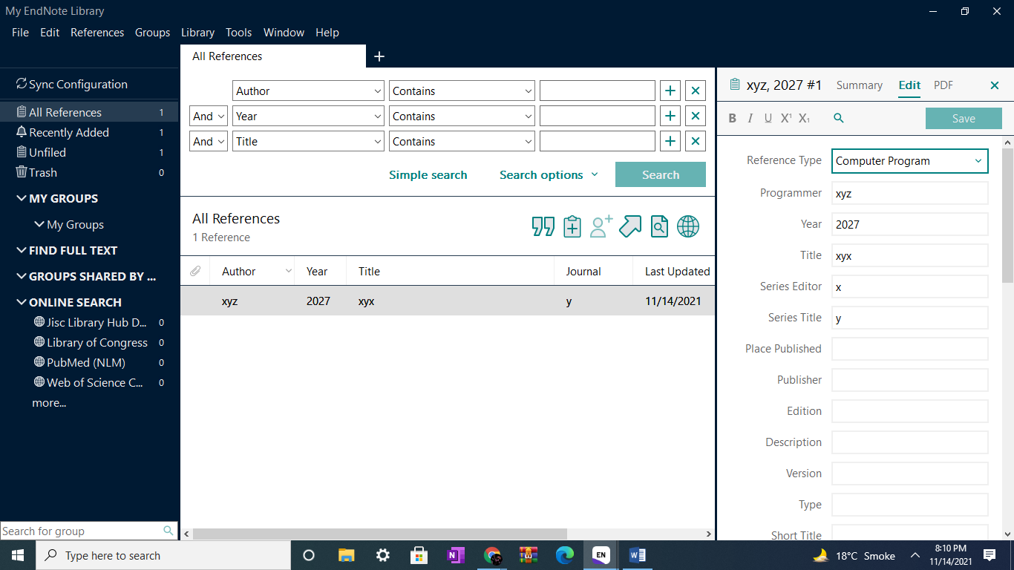

* On the left side, you can edit or manage your citation as you wanted.

**Saving Selected References or Citations from Online Sources:**

For saving selected references or citations from online sources, you have to follow the following step to save selected references or citations from online sources.

* There is an option of the ‘Online Search’ on the left.
* In ‘Online Search’, there is an option of ‘Library of Congress’
* Click on the Library of Congress.
* After clicking on the Library of Congress, We have to put the information regarding of the reference.

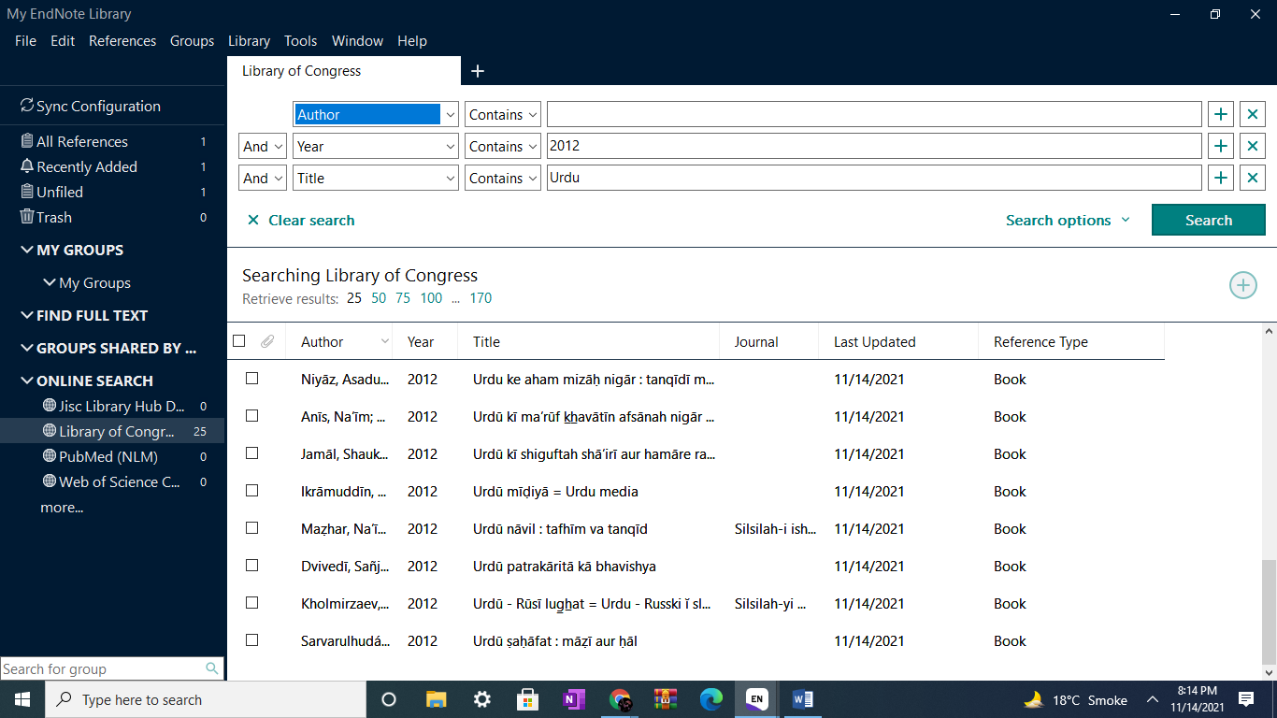

* After putting the information, there are the list of the reference regarding the information you have provide.

**Instant Formatting:**

Instant Formatting will help you to format the document while you are working or writing on it. For Instant Formatting, you have to follow the following step to instant formatting.

* Click the tools on the top left side.
* After clicking the tools, there is an option of Cite While Your Write.
* Click on the Cite While Your Write.
* After clicking on the Cite While Your Write, there is an option of Cite While Your Write Preferences.
* Click on the Cite While Your Write Preferences.
* After this, it will help you to format instant.

